 | Rajalakshmi Engineering College  (An Autonomous Institution) Rajalakshmi Nagar, Thandalam-602105

ONLINE BUS PASS APPLICATION SYSTEM

WEEK 2
PROGRAM1
Develop and demonstrate the usage of Inline, Internal and External style sheet using CSS

<!DOCTYPE html>
<html>
<head>
<title>Online Bus Pass Application</title>
<link rel="stylesheet" href="style.css">
</head>
<body>

<h1>Online Bus Pass Application Form</h1>

<form>
<label>Full Name:</label>
<input type="text" placeholder="Enter your name" required>

<label>Email:</label>
<input type="email" placeholder="Enter your email" required>

<label>Mobile Number:</label>
<input type="tel" placeholder="Enter mobile number" required>

<label>Address:</label>
<textarea placeholder="Enter your address"></textarea>

<label>Source:</label>
<input type="text" placeholder="From">

<label>Destination:</label>
<input type="text" placeholder="To">

<label>Pass Type:</label>
<select>
<option>Student</option>
<option>Monthly</option>
<option>Senior Citizen</option>
</select>

<button type="submit">Apply Now</button>
</form>

</body>
</html>

body {
font-family: Arial;
background-color: #f2f2f2;
}

h1 {
text-align: center;
color: darkblue;
}

form {
width: 400px;
margin: auto;
padding: 20px;
background-color: white;
border-radius: 8px;
}

label {
font-weight: bold;
}

input, textarea, select {
width: 100%;
padding: 8px;
margin: 8px 0;
}

button {
width: 100%;
padding: 10px;
background-color: green;
color: white;
border: none;
border-radius: 5px;
}

OUTPUT: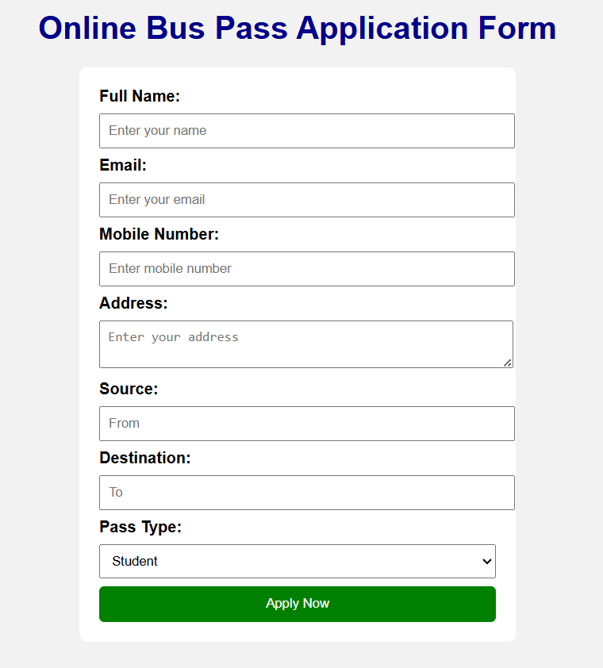

PROGRAM 2
Design a Student Record Web Page Using CSS Keyframe Animation

<!DOCTYPE html>
<html>
<head>
<title>Student Record - Animation</title>

<style>
body {
font-family: Arial, sans-serif;
background: #f2f2f2;
display: flex;
justify-content: center;
align-items: center;
height: 100vh;
}

.card {
width: 450px;
padding: 25px;
background: white;
border-radius: 12px;
box-shadow: 0px 0px 15px rgba(0,0,0,0.2);
animation: slideIn 2s ease;
}

h2 {
text-align: center;
color: darkblue;
animation: glowText 2s infinite alternate;
}

table {
width: 100%;
margin-top: 15px;
border-collapse: collapse;
}

td {
padding: 10px;
border: 1px solid #ccc;
}

.label {
font-weight: bold;
background: #e0e0ff;
width: 40%;
}

/* Keyframe Animations */

@keyframes slideIn {
from {
transform: translateY(-60px);
opacity: 0;
}
to {
transform: translateY(0);
opacity: 1;
}
}

@keyframes glowText {
from {
color: darkblue;
text-shadow: 0 0 5px skyblue;
}
to {
color: red;
text-shadow: 0 0 10px orange;
}
}
</style>

</head>
<body>

<div class="card">
<h2>Student Record</h2>

<table>
<tr>
<td class="label">Student Name</td>
<td>Rahul Sharma</td>
</tr>
<tr>
<td class="label">Roll Number</td>
<td>CS101</td>
</tr>
<tr>
<td class="label">Course</td>
<td>B.Tech CSE</td>
</tr>
<tr>
<td class="label">Semester</td>
<td>4</td>
</tr>
<tr>
<td class="label">Email</td>
<td>rahul@gmail.com</td>
</tr>
<tr>
<td class="label">Phone</td>
<td>9876543210</td>
</tr>
</table>
</div>

</body>
</html>

OUTPUT: -------------------------------------------------
| |
| Student Record | ← Glowing animated text
| |
| ----------------------------------------- |
| | Student Name | Rahul Sharma | |
| | Roll Number | CS101 | |
| | Course | B.Tech CSE | |
| | Semester | 4 | |
| | Email | rahul@gmail.com | |
| | Phone | 9876543210 | |
| ----------------------------------------- |
| |
-------------------------------------------------

